CMR INSTITUTE OF TECHNOLOGY

Affiliated to Visvesvaraya Technological University (VTU)
Sri Nivasa Reddy Layout, AECS Layout, Marathahalli,
Bengaluru, Karnataka 560037


Department of Information Science and Engineering
LAB MANUAL

FULL STACK DEVELOMENT (BIS601)

Semester-VI
Scheme-2022

PRACTICAL COMPONENT OF IPCC
Sl.NO | Experiments
1 | a. Write a script that Logs "Hello, World!" to the console. Create a script that calculates the sum of two numbers and displays the result in an alert box.  b. Create an array of 5 cities and perform the following operations:  Log the total number of cities. Add a new city at the end. Remove the first city. Find and log the index of a specific city.
2 | a. Read a string from the user, Find its length. Extract the word "JavaScript" using substring() or slice(). Replace one word with another word and log the new string. Write a function is Palindrome(str) that checks if a given string is a palindrome (reads the same backward).
3 | Create an object student with properties: name (string), grade (number), subjects (array), display Info() (method to log the student's details)  Write a script to dynamically add a passed property to the student object, with a value of true or false based on their grade. Create a loop to log all keys and values of the student object.
4 | Create a button in your HTML with the text "Click Me". Add an event listener to log "Button clicked!" to the console when the button is clicked. Select an image and add a mouseover event listener to change its border color. Add an event listener to the document that logs the key pressed by the user.
5 | Build a React application to track issues. Display a list of issues (use static data). Each issue should have a title, description, and status (e.g., Open/Closed). Render the list using a functional component.
6 | Create a component Counter with A state variable count initialized to 0. Create Buttons to increment and decrement the count. Simulate fetching initial data for the Counter component using use Effect (functional component) or component DidMount (class component). Extend the Counter component to Double the count value when a button is clicked. Reset the count to 0 using another button.
7 | Install Express (npm install express).  Set up a basic server that responds with "Hello, Express!" at the root endpoint (GET /).  Create a REST API. Implement endpoints for a Product resource: GET : Returns a list of products. POST : Adds a new product. GET /:id: Returns details of a specific product. PUT /:id: Updates an existing product. DELETE /:id: Deletes a product. Add middleware to log requests to the console. Use express.json() to parse incoming JSON payloads.
8 | Install the MongoDB driver for Node.js. Create a Node.js script to connect to the shop database. Implement insert, find, update, and delete operations using the Node.js MongoDB driver. Define a product schema using Mongoose. Insert data into the products collection using Mongoose. Create an Express API with a /products endpoint to fetch all products. Use fetch in React to call the /products endpoint and display the list of products. Add a POST /products endpoint in Express to insert a new product. Update the Product List, After adding a product, update the list of products displayed in React.

FSD LAB
References
https://www.youtube.com/watch?v=E8lXC2mR6-k
Remove-Item * -Recurse -Force
1. a. Write a script that Logs "Hello, World!" to the console. Create a script that calculates the sum of two numbers and displays the result in an alert box.
b. Create an array of 5 cities and perform the following operations:
Log the total number of cities. Add a new city at the end. Remove the first city. Find and log the index of a specific city.

- Install Node.js:
  - Download: Go to the Node.js official website and download the latest version suitable for Windows.
  - Install: Run the downloaded installer and follow the on-screen instructions to install Node.js. This will also install npm (Node Package Manager), which is useful for managing JavaScript packages.
- Set Up Your Environment:
  - Text Editor: Use a text editor like Visual Studio Code or any other text editor of your choice.
  - Command Line: Use the Command Prompt or PowerShell to run your JavaScript files.
- Running the Script:
  - Save Your Script: Save the above JavaScript code in a file with a .js extension, e.g., script.js.
  - Execute the Script:
    - Open the Command Prompt or PowerShell.
    - Navigate to the directory where your script.js file is located.
    - Run the script using Node.js by typing:

shell
node script.js
    - This will execute the JavaScript code and you will see the output in the console.
By following these steps, you can run and test the JavaScript programs on your Windows desktop.

To know the node.js version
=========================
node -v

experiment1a.js
// Script to log "Hello, World!" to the console
console.log("Hello, World!");

// Script to calculate the sum of two numbers and display the result in an alert box
function calculateSum(a, b) {
return sum = a + b;
}

// Example usage
if (typeof alert === "function") {
alert("The sum of 5 and 7 is: " + calculateSum(5, 7));
} else {
console.log("The sum of 5 and 7 is: " + calculateSum(5, 7));
}

index.html to make working of alert function
<!DOCTYPE html>
<html>
<head>
<title>JavaScript Example</title>
</head>
<body>
<script src="experiment1a.js"></script>
</body>
</html>

o/p:
just click on index.html icon to see the result.

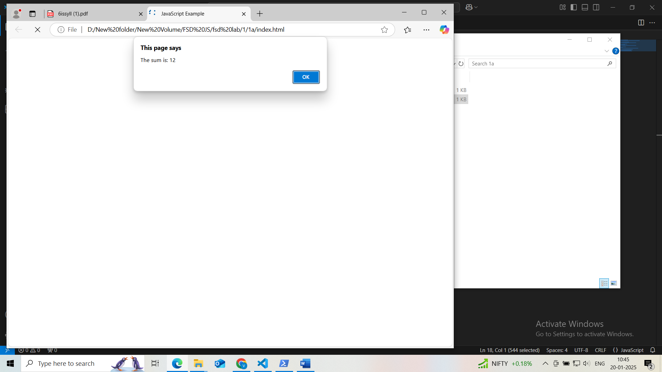
Some other way like whole thing implemented in single html file
1a.html
=======================
<!DOCTYPE html>
<head>
<title>Dynamic Input Example</title>
<script>
// Script to log "Hello, World!" to the console
console.log("Hello, World!");

// Script to calculate the sum of two numbers and display the result in an alert box
// Read numbers from user input
let num1 = parseFloat(prompt("Enter the first number:"));
let num2 = parseFloat(prompt("Enter the second number:"));

// Validate input
let sum = num1 + num2;
alert("The sum is: " + sum);

// Example usage

</script>
</head>
</html>
o/p:

1b.js
const prompt = require('prompt-sync')();

// Prompt the user to enter 5 city names, separated by commas
let input = prompt("Enter 5 cities separated by commas: ");
let cities = input.split(',').map(city => city.trim());
console.log("Initial cities:", cities);

// Log the total number of cities
console.log("Total number of cities:", cities.length);

// Add a new city at the end
let newCity = prompt("Enter a city to add to the end: ");
cities.push(newCity);
console.log("Cities after adding a new one:", cities);

// Remove the first city
console.log("Removing the first city:", cities[0]); // Log the first city before removal
cities.shift();
console.log("Cities after removing the first one:", cities);

// Find and log the index of a specific city
let searchCity = prompt("Enter a city to find its index: ");
let cityIndex = cities.indexOf(searchCity);
console.log("Index of", searchCity + ":", cityIndex !== -1 ? cityIndex : "City not found");

1bb.html
<!DOCTYPE html>
<html lang="en">
<head>
<meta charset="UTF-8">
<meta name="viewport" content="width=device-width, initial-scale=1.0">
<title>Dynamic Cities Array</title>
</head>
<body>
<h1>Dynamic Cities Array</h1>
<script src="1b.js"></script>
</body>
</html>
Execution
First install node js
Next run
npm install prompt-sync
node 1b.js

o/p: node 1b.js
i/p: New York, London, Paris, Tokyo, Sydney

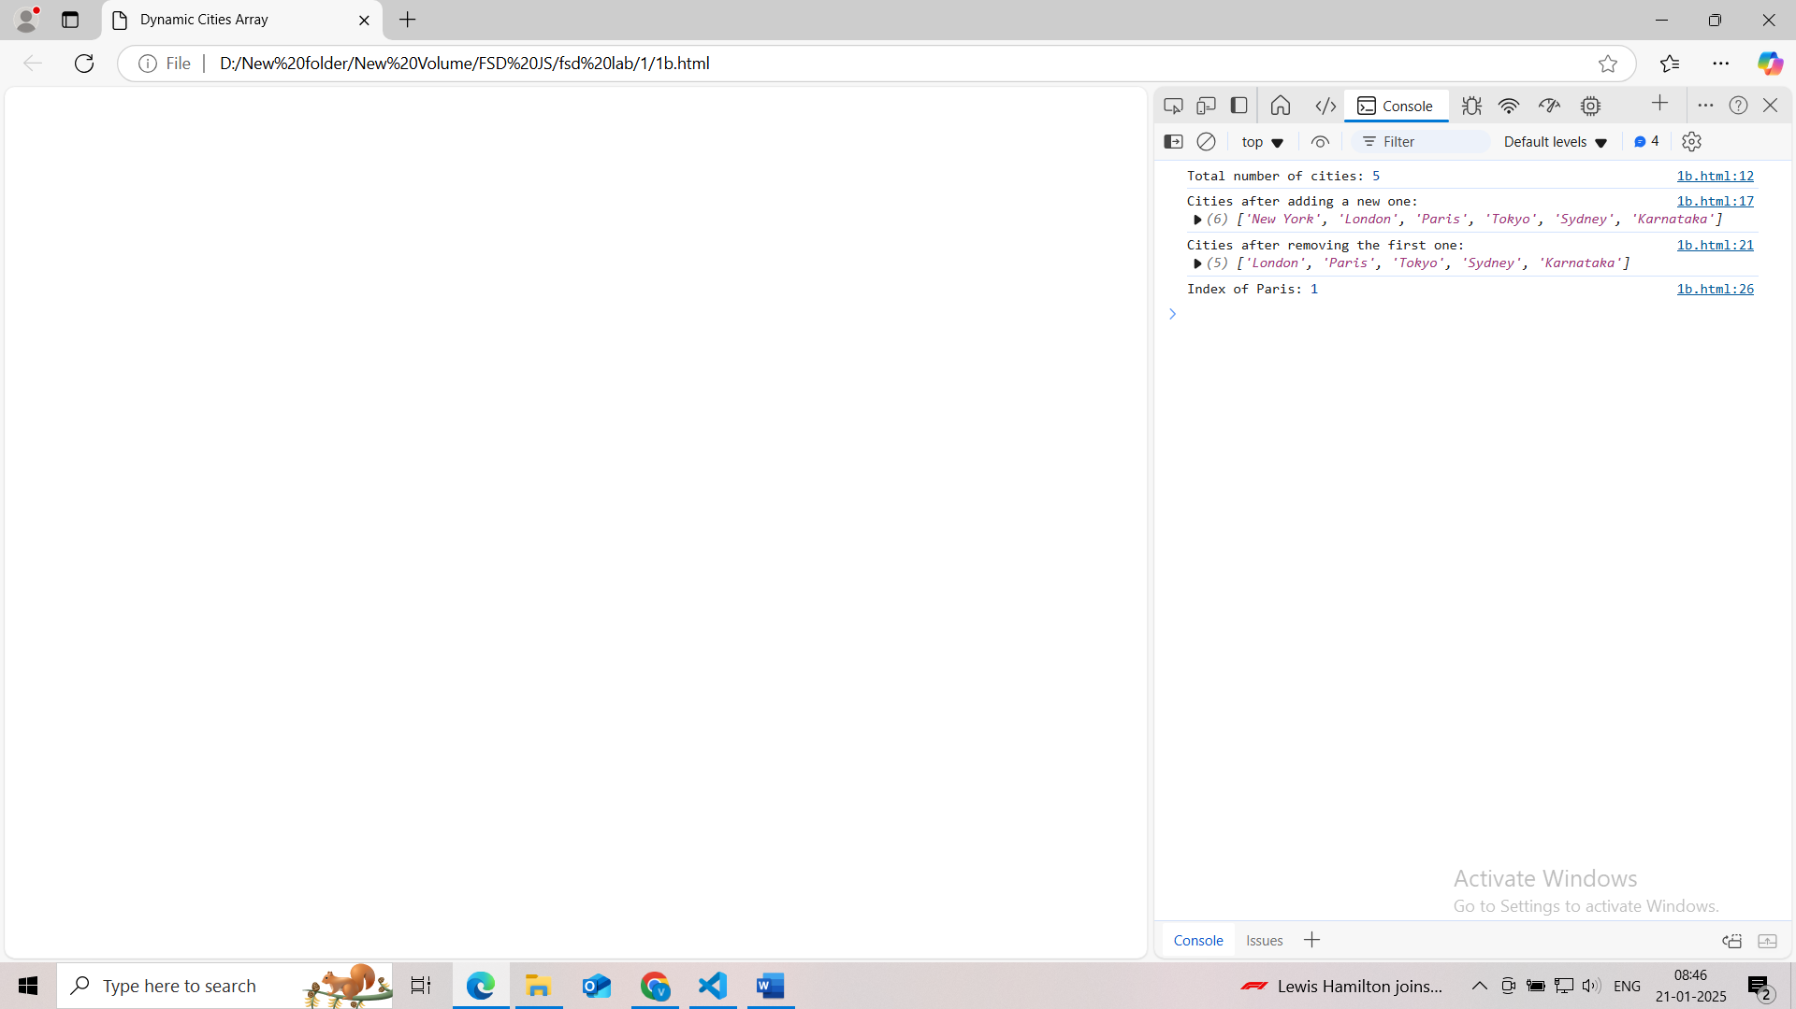
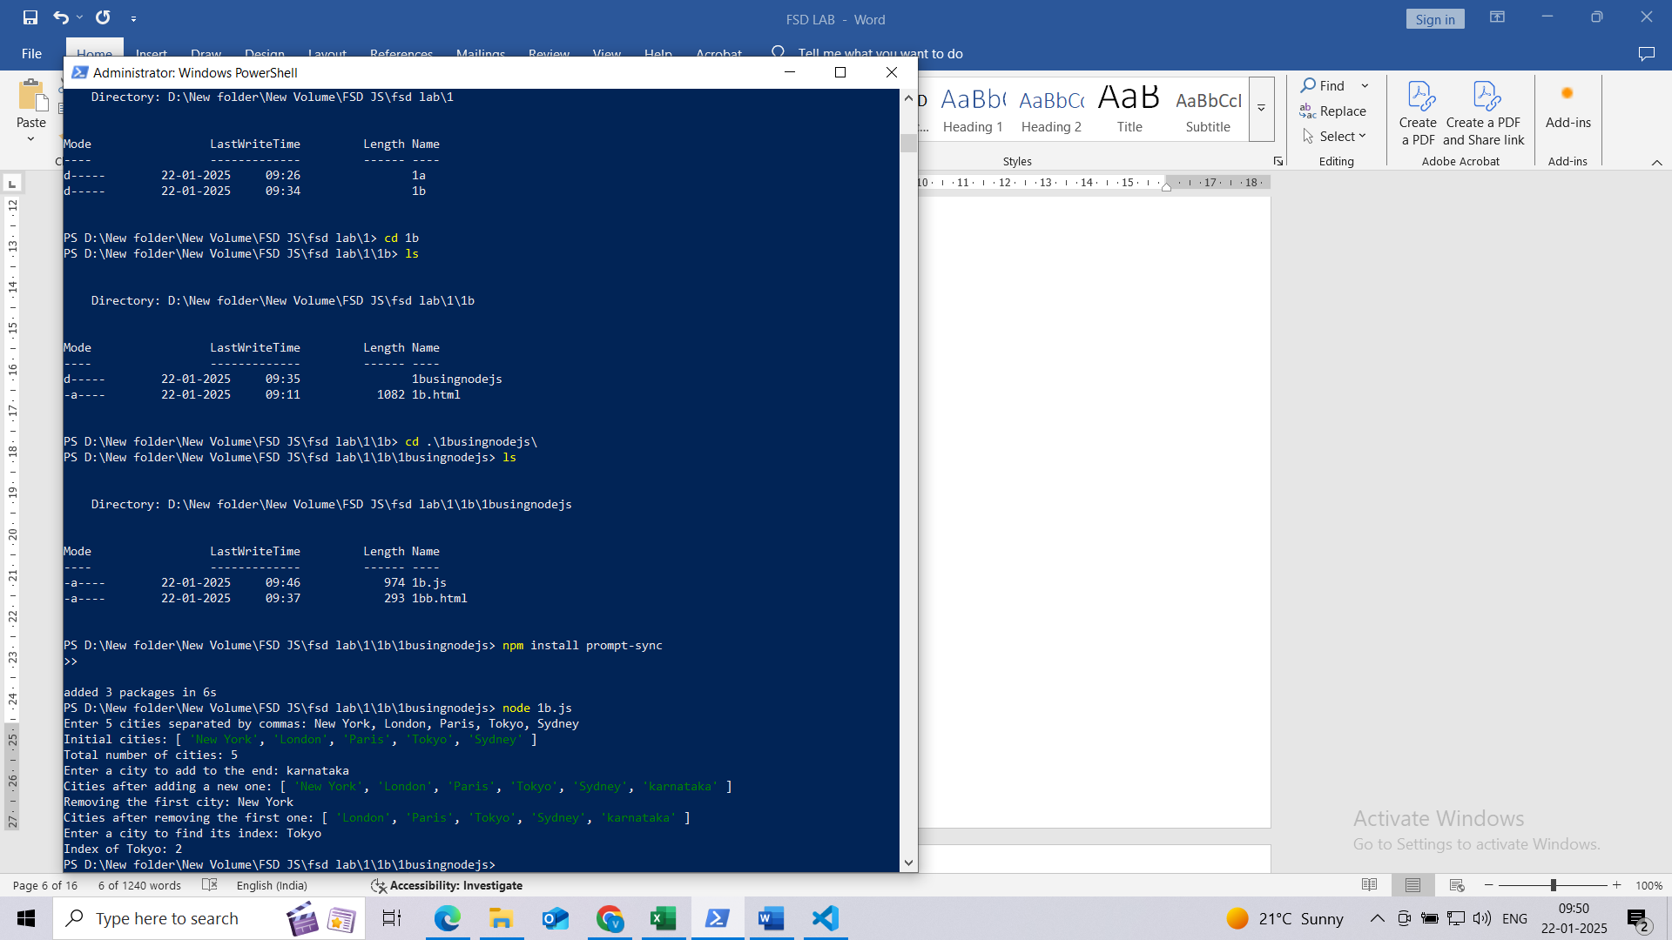
2. Read a string from the user, Find its length. Extract the word "JavaScript" using substring() or slice(). Replace one word with another word and log the new string. Write a function isPalindrome(str) that checks if a given string is a palindrome (reads the same backward).

<!DOCTYPE html>
<head>

<title>String Manipulation</title>
<script>
// Function to check if a string is a palindrome
function isPalindrome1(str) {
for (let i = 0; i < str.length / 2; i++) {
if (str.charAt(i) != str.charAt(str.length - 1 - i)) {
return false;
}
}
return true;
}

function isPalindrome(str) {
let cleanedStr = str.replace(/[^A-Za-z0-9]/g, '').toLowerCase();
return cleanedStr === cleanedStr.split('').reverse().join('');
}

// Read string from user and perform operations
let userInput = prompt("Enter a string:");
let lengthOfString = userInput.length;

// Extract 'JavaScript' and replace if present
let extractedWord = userInput.includes("JavaScript") ? userInput.substring(userInput.indexOf("JavaScript"), userInput.indexOf("JavaScript") + "JavaScript".length) : "JavaScript not found";
let newString = userInput.replace("JavaScript", "TypeScript");
let palindromeCheck = isPalindrome(userInput);

// Log results
console.log(`New String after Replacement: ${newString}`);

// Display alerts
alert(`Length: ${lengthOfString}\nExtracted Word: ${extractedWord}\nNew String: ${newString}\nPalindrome: ${palindromeCheck}`);
</script>

</head>
</html>

o/p:
give the input string as -------------I love JavaScript, it is awesome!
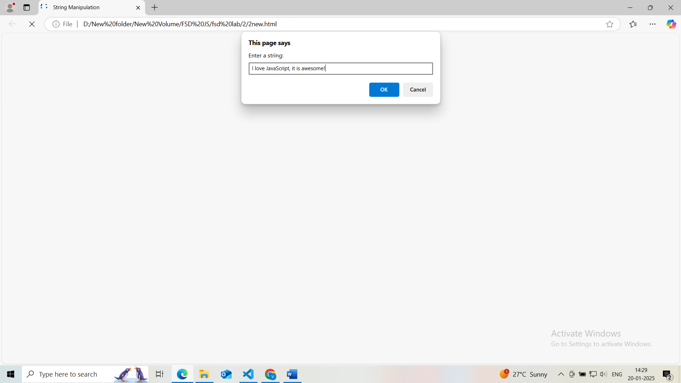

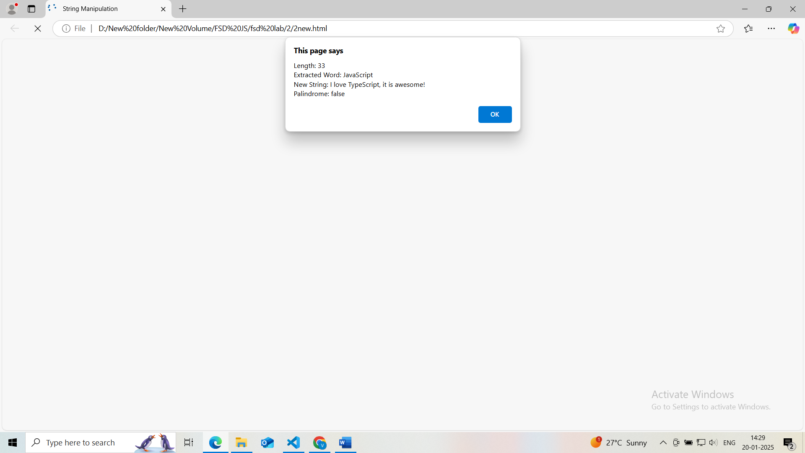

- Create an object student with properties: name (string), grade (number), subjects (array), displayInfo() (method to log the student's details) Write a script to dynamically add a passed property to the student object, with a value of true or false based on their grade. Create a loop to log all keys and values of the student object.
One student
<!DOCTYPE html>

<head>

<title>Dynamic Student Object</title>
<script>
// Function to create a student object
function createStudent() {
// Collect inputs for the student object
let student = {
name: prompt("Enter the student's name:"),
grade: parseInt(prompt("Enter the student's grade:")),
subjects: prompt("Enter the student's subjects separated by commas:").split(',').map(subject => subject.trim()),
};
return student;
}

// Function to display student details
function displayInfo(student) {
console.log("Student Details:");

// Loop through the properties of the student object and log the keys and values
for (let key in student) {
if (typeof student[key] !== 'function') {
console.log(`${key}: ${student[key]}`);
}
}

// Log whether the student passed based on the 'passed' function
console.log("Passed:", student.passed() ? "Yes" : "No");
console.log("------------------------------");
}

let student = createStudent(); // Collect details and return student object
// Dynamically add 'passed' property based on grade
student.passed = student.grade >= 40;
displayInfo(student);
</script>
</head>

</html>

Many students
<!DOCTYPE html>

<head>

<title>Dynamic Student Object</title>
<script>
// Function to create a student object
function createStudent() {
// Collect dynamic inputs for the student object
let student = {
name: prompt("Enter the student's name:"),
grade: parseFloat(prompt("Enter the student's grade:")),
subjects: prompt("Enter the student's subjects separated by commas:").split(',').map(subject => subject.trim()),

// Dynamically add 'passed' property based on grade
passed: function() {
return this.grade >= 50;
}
};
return student;
}

// Function to display student details
function displayInfo(student) {
console.log("Student Details:");

// Loop through the properties of the student object and log the keys and values
for (let key in student) {
if (typeof student[key] !== 'function') {
console.log(`${key}: ${student[key]}`);
}
}

// Log whether the student passed based on the 'passed' function
console.log("Passed:", student.passed() ? "Yes" : "No");
console.log("------------------------------");
}

// Collect details for multiple students
let numStudents = parseInt(prompt("How many students' details would you like to enter?"));

// Loop to collect details for each student
for (let i = 0; i < numStudents; i++) {
console.log(`Enter details for student #${i + 1}:`);
let student = createStudent(); // Collect details and return student object
displayInfo(student);
}

</script>
</head>

</html>

o/p:
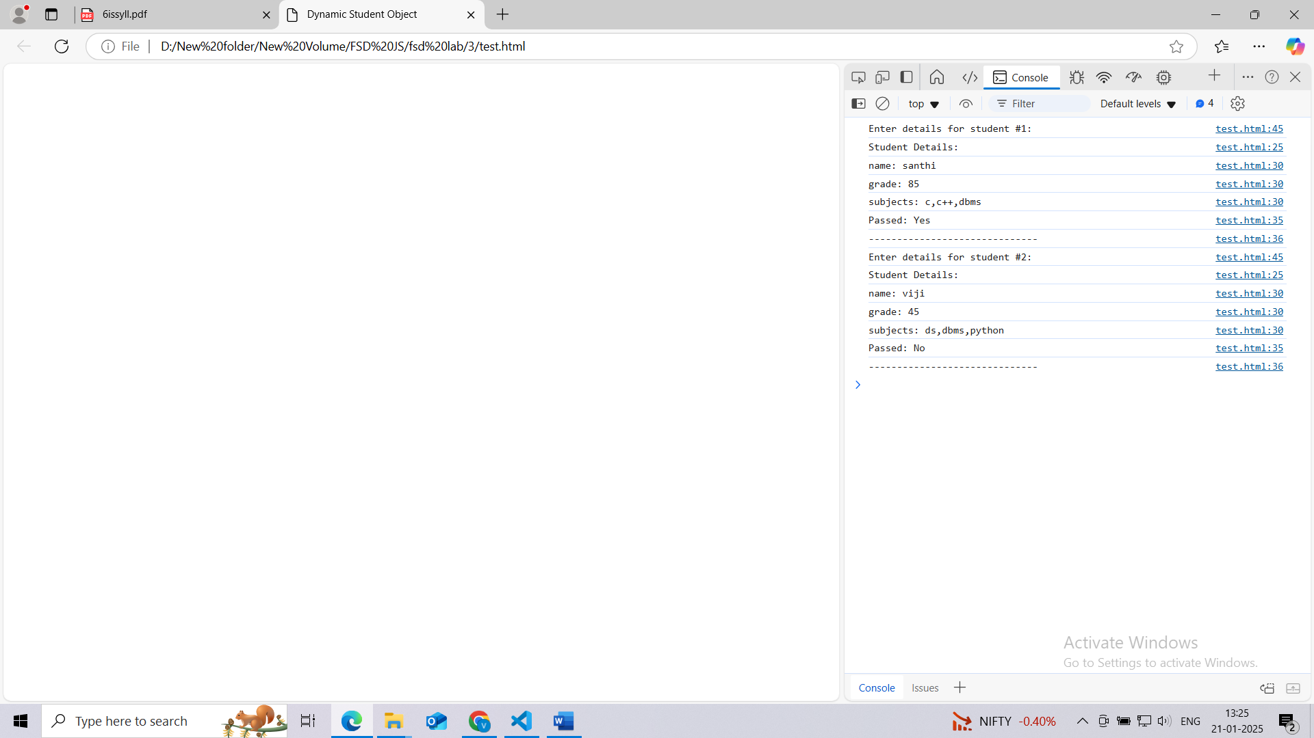

4. Create a button in your HTML with the text "Click Me". Add an event listener to log "Button clicked!" to the console when the button is clicked. Select an image and add a mouseover event listener to change its border color. Add an event listener to the document that logs the key pressed by the user.

<!DOCTYPE html>
<head>

<title>Event Listeners Example</title>
</head>
<body>

<!-- Button to click -->
<button id="clickButton">Click Me</button>

<!-- Example image with a reliable URL -->
<img id="exampleImage" src="https://www.w3schools.com/html/img_chania.jpg" alt="Example Image" width="200">

<script>
// Event listener for the button click
document.getElementById('clickButton').addEventListener('click', function() {
console.log("Button clicked!");
});

// Event listener for mouseover on the image to change its border color
document.getElementById('exampleImage').addEventListener('mouseover', function() {
this.style.border = '5px solid red'; // Change border color to red
});

// Event listener to log the key pressed by the user
document.addEventListener('keydown', function(event) {
console.log("Key pressed: " + event.key);
});

// Event listener for mouseout on the image to change its border color
document.getElementById('exampleImage').addEventListener('mouseout', function() {
this.style.border = 'none'; // remove the border
});

</script>

</body>
</html>

o/p:
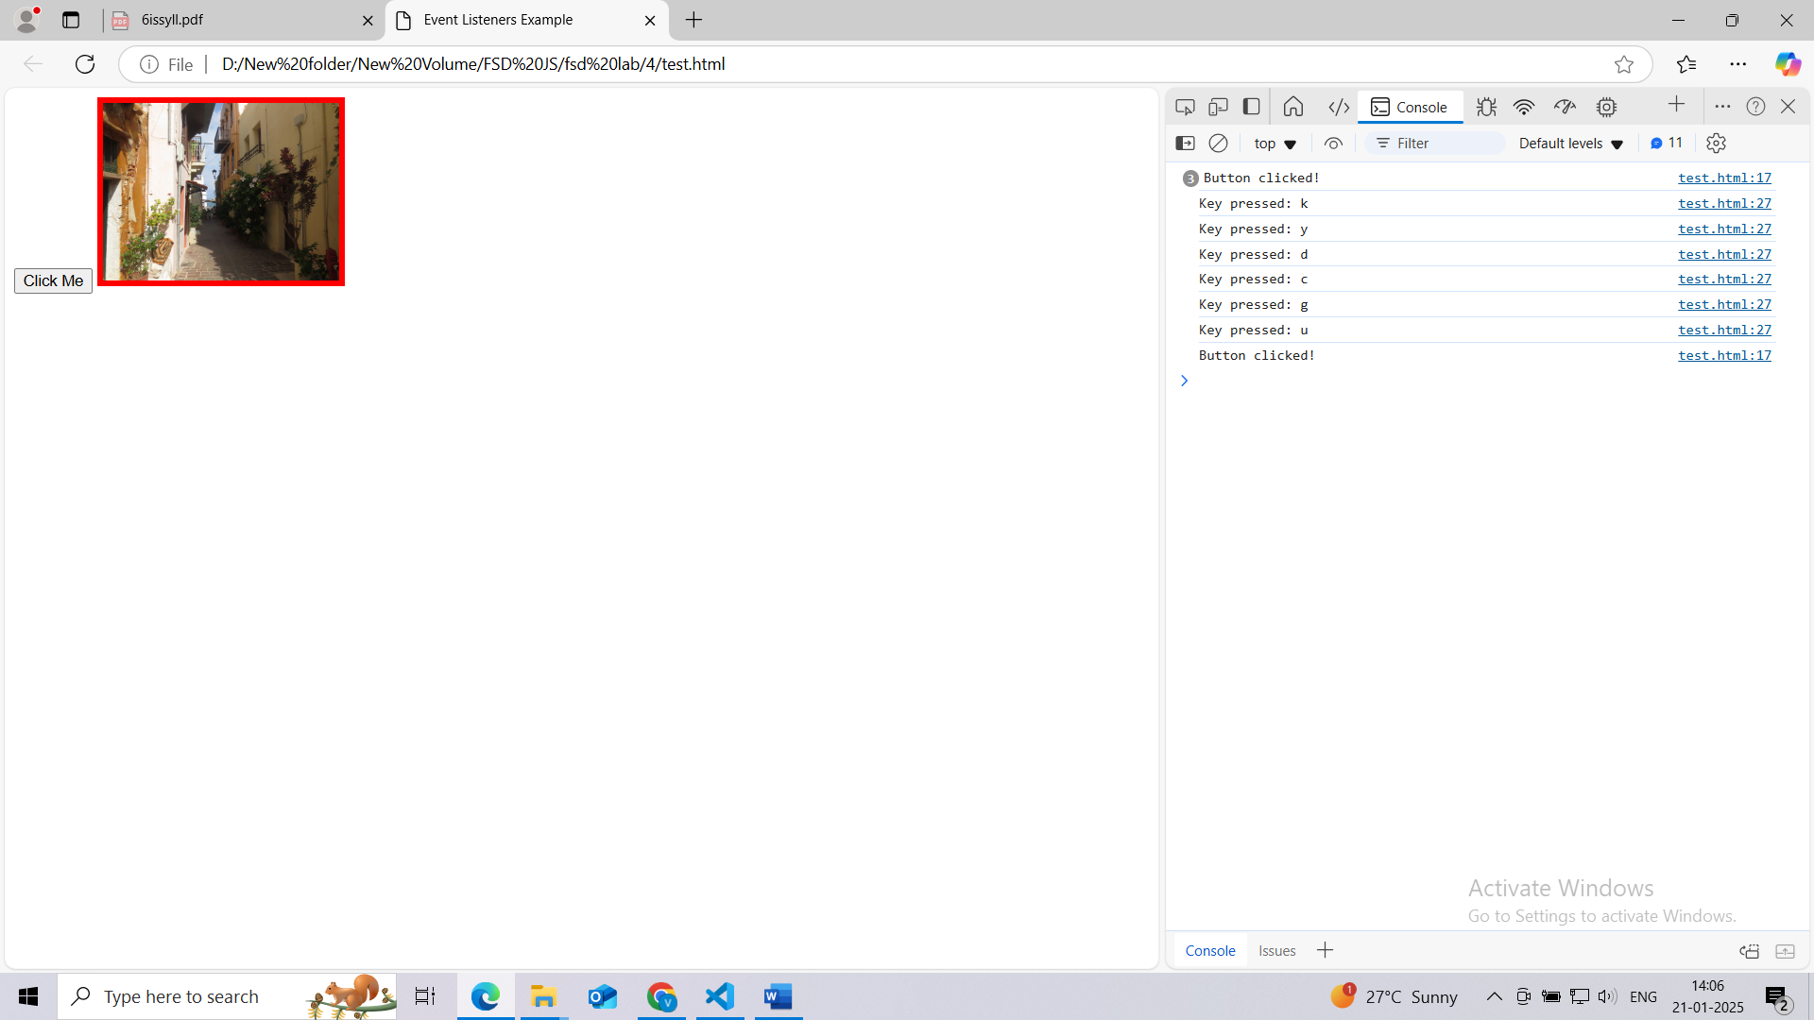
5. Build a React application to track issues. Display a list of issues (use static data). Each issue should have a title, description, and status (e.g., Open/Closed). Render the list using a functional component.
• Initialize the Project:
Vite variations
Vanilla
Vue
React
Preact
Lit
Svelte
Solid
Qwik
Angular
Others
npm create vite@latest issue-tracker --template react
cd issue-tracker
• Install Dependencies:
npm install
• Start the Development Server:
npm run dev
• Create the Functional Component:
- Inside src, create a file named IssueList.jsx with the following content:
import React from 'react';

const issues = [
{ id: 1, title: 'Bug in Login', description: 'Error 404 on login', status: 'Open' },
{ id: 2, title: 'UI Issue on Dashboard', description: 'Misaligned elements', status: 'Closed' },
{ id: 3, title: 'API Timeout', description: 'Delayed response from server', status: 'Open' },
];

function IssueList() {
return (
<div>
<h1>Issue Tracker</h1>
<ul>
{issues.map(issue => (
<li key={issue.id}>
<h2>{issue.title}</h2>
<p>{issue.description}</p>
<p>Status: {issue.status}</p>
</li>
))}
</ul>
</div>
);
}

export default IssueList;
• Render the Component in App.jsx:
- Modify App.jsx to include the IssueList component:
import React from 'react';
import IssueList from './IssueList';

function App() {
return (
<div>
<IssueList />
</div>
);
}

export default App;
• Run and View the Application:
- Start the development server if it’s not already running:
npm run dev
- Visit http://localhost:3000 to view the issue tracker in the browser.
Or
VITE v6.0.11 ready in 1957 ms

➜ Local: http://localhost:5173/
➜ Network: use --host to expose
➜ press h + enter to show help

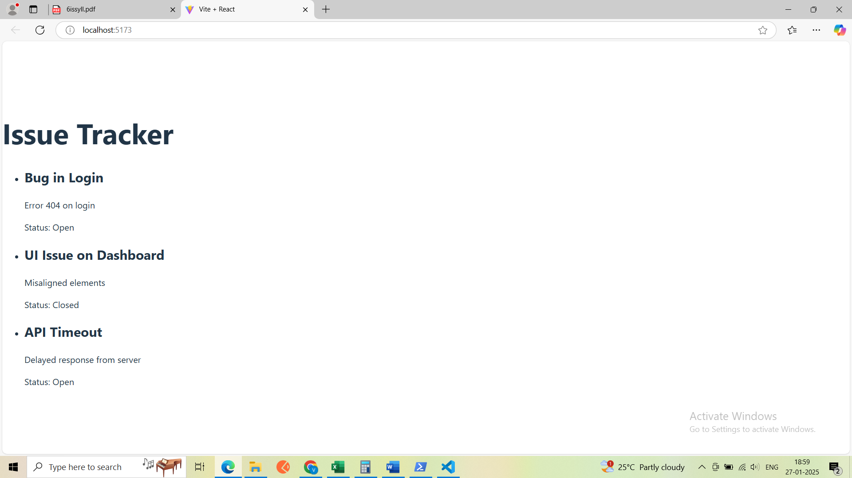

6. Create a component Counter with A state variable count initialized to 0. Create Buttons to increment and decrement the count. Simulate fetching initial data for the Counter component using useEffect (functional component) or componentDidMount (class component). Extend the Counter component to Double the count value when a button is clicked. Reset the count to 0 using another button.

Steps for reactjs:
Old approach
================
1. First install GIT
2. Ensure you are installing a compatible version of React, such as react@18. Run the following command to create the React app with a specific version:
npx create-react-app counter-app

3.Or using Vite
npm create vite@latest counter-app
cd counter-app
npm install
npm run dev

modify App.jsx In src folder
import React from 'react';
import Counter from './Counter'; // Ensure the correct import path
import './App.css'; // Optional, only if you have this file

function App() {
return (
<div className="App">
<h1>Welcome to Counter App</h1>
<Counter />
</div>
);
}
export default App;

create src/Counter.jsx in src folder
import React, { useState, useEffect } from 'react';

const Counter = () => {
const [count, setCount] = useState(0);

// Simulate fetching initial data for the Counter component
useEffect(() => {
setTimeout(() => {
setCount(0); // Set initial value after 2 seconds
}, 2000);
}, []);

return (
<div>
<h1>Counter: {count}</h1>
<button onClick={() => setCount(count + 1)}>Increment</button>
<button onClick={() => setCount(count - 1)}>Decrement</button>
<button onClick={() => setCount(count * 2)}>Double</button>
<button onClick={() => setCount(0)}>Reset</button>
</div>
);
};

export default Counter;

steps for next js

- npx create-next-app@latest counter-app
Options to Select:
- Would you like to use TypeScript?
No (Choose "Yes" if you want TypeScript, but if you prefer simplicity, select "No").
- Would you like to use ESLint?
Yes (Recommended for maintaining code quality, especially in team projects).
- Would you like to use Tailwind CSS?
No (Select "Yes" if you plan to style your app using Tailwind CSS, but it's unnecessary for this Counter example).
- Would you like your code inside a src/ directory?
Yes (This organizes your files better, making the project structure clean and scalable).
- Would you like to use App Router? (recommended)
Yes (This uses the latest Next.js routing features introduced in version 13).
- Would you like to use Turbopack for next dev?
Yes (Recommended for faster development builds; it's experimental but stable for many use cases).
- Would you like to customize the import alias (@/* by default)?
No (Stick with the default unless you have specific aliasing requirements).
TypeScript? No
ESLint? Yes
Tailwind CSS? No
Code inside `src/`? Yes
App Router? Yes
Turbopack for `next dev`? Yes
Import alias customization? No

Peocedure
- Very simple put Counter.jx code In the folder like by creating Counter.js in src/app/Counter.js. and also add 'use client'; as first line in this file.
- Moify the page.js content with src/App.Jsx by removing importing of App.jsx
Create Src\app\Counter.js
'use client';
import React, { useState } from 'react';

const Counter = () => {
const [count, setCount] = useState(0); // Directly setting the initial value

return (
<div>
<h1>Counter: {count}</h1>
<button onClick={() => setCount(count + 1)}>Increment</button>
<button onClick={() => setCount(count - 1)}>Decrement</button>
<button onClick={() => setCount(count * 2)}>Double</button>
<button onClick={() => setCount(0)}>Reset</button>
</div>
);
};

export default Counter;

src\app\page.js
import React from 'react';
import Counter from './Counter';

function App() {
return (
<div className="App">
<h1>Welcome to Counter App</h1>
<Counter />
</div>
);
}

export default App;

o/p:
npm run dev

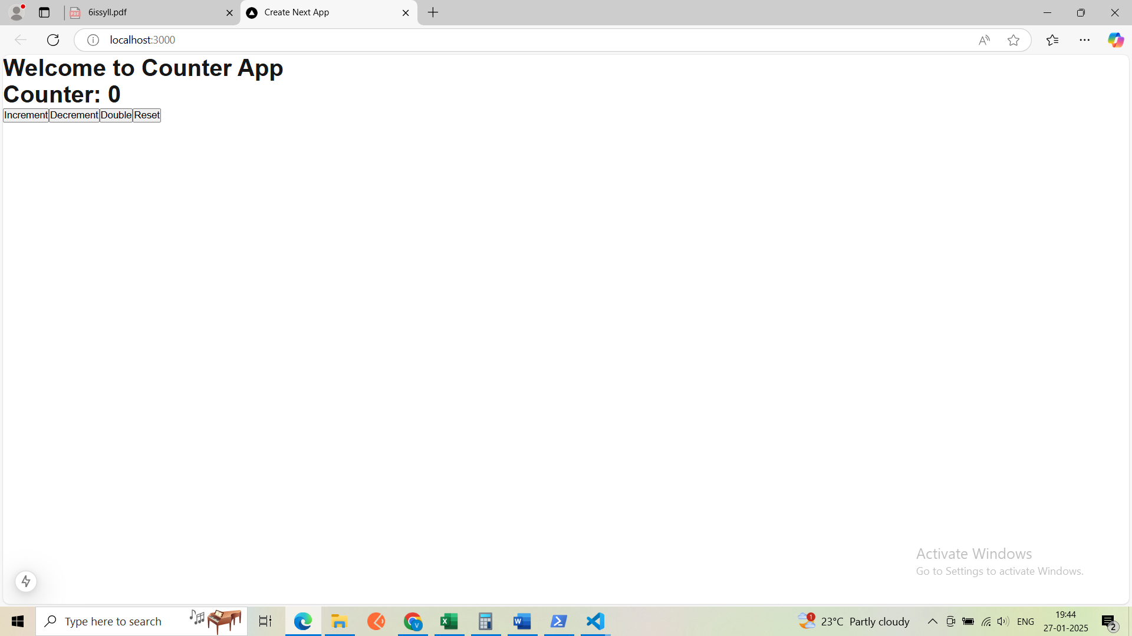

7. Install Express (npm install express). Set up a basic server that responds with "Hello, Express!" at the root endpoint (GET /). Create a REST API. Implement endpoints for a Product resource: GET : Returns a list of products. POST : Adds a new product. GET /:id: Returns details of a specific product. PUT /:id: Updates an existing product. DELETE /:id: Deletes a product. Add middleware to log requests to the console. Use express.json() to parse incoming JSON payloads.
Step-by-Step Process:
- Install Node.js and npm
  - If you don't have Node.js installed, go to the official website: Node.js and install the LTS version. This will automatically install npm (Node Package Manager) as well.
- Create a new Project Directory
  - Open your terminal/command prompt and create a new directory for your mkdir express-product-api
cd express-product-api
- Initialize the Project
  - Run npm init -y to create a package.json file:
npm init -y
- Install Express
  - Now, install Express by running the following command:
npm install express
- Create the Server File
  - Create a file named app.js in your project directory.
touch app.js
- Set Up Basic Server with Middleware
Open the app.js file and add the following code:

const express = require('express');
const app = express();
const port = 3000;

// Middleware
app.use(express.json()); // Parse JSON payloads
app.use((req, res, next) => {
console.log(`${req.method} ${req.url}`);
next();
});

// In-memory product storage
let products = [
{ id: 1, name: 'Laptop', price: 1000 },
{ id: 2, name: 'Phone', price: 500 }
];

// Routes
app.get('/', (req, res) => res.send('Hello, Express!'));

app.route('/products')
.get((req, res) => res.json(products)) // GET: List all products
.post((req, res) => { // POST: Add a new product
const newProduct = { id: products.length + 1, ...req.body };
products.push(newProduct);
res.status(201).json(newProduct);
});

app.route('/products/:id')
.get((req, res) => { // GET: Get a product by ID
const product = products.find(p => p.id === +req.params.id);
product ? res.json(product) : res.status(404).send('Product not found');
})
.put((req, res) => { // PUT: Update a product by ID
const product = products.find(p => p.id === +req.params.id);
if (product) {
Object.assign(product, req.body);
res.json(product);
} else {
res.status(404).send('Product not found');
}
})
.delete((req, res) => { // DELETE: Delete a product by ID
const index = products.findIndex(p => p.id === +req.params.id);
if (index !== -1) {
res.json(products.splice(index, 1));
} else {
res.status(404).send('Product not found');
}
});

// Start server
app.listen(port, () => console.log(`Server is running at http://localhost:${port}`));

7. Run the Server
- Start the server by running:
node app.js
You should see the following output in your terminal:
Server is running at http://localhost:3000
8. output: Test the API with Postman or cURL
- Now you can test the endpoints using cURL:
  - GET /products: Retrieve all products.
  - POST /products: Add a new product (e.g., {"name": "Tablet", "price": 300}).
  - GET /products/:id: Retrieve a specific product by ID.
  - PUT /products/:id: Update a product's name and price.
  - DELETE /products/:id: Delete a product by ID.
For this first install curl using
choco install curl,
Get-Command curl ,
C:\ProgramData\chocolatey\lib\curl\tools\curl.exe –version,
Remove-Item Alias:curl,
curl --version
Example cURL commands:
- GET all products:
curl http://localhost:3000/products
- POST new product:
Using curl
curl -X POST http://localhost:3000/products -H "Content-Type: application/json" -d '{\"name\":\"Tablet\",\"price\":300}'
if curl is aliased with webrequest then work on below.
Invoke-WebRequest -Uri http://localhost:3000/products -Method POST -Headers @{ "Content-Type" = "application/json" } -Body '{"name": "Tablet", "price": 300}'
- GET product by ID:
curl http://localhost:3000/products/1
- PUT update product:
curl -X PUT http://localhost:3000/products/1 -H "Content-Type: application/json" -d '{"name": "Updated Laptop", "price": 1200}'
or
Invoke-WebRequest -Uri http://localhost:3000/products/1 -Method PUT -Headers @{ "Content-Type" = "application/json" } -Body '{"name": "Updated Laptop", "price": 1200}'
- DELETE product:
curl -X DELETE http://localhost:3000/products/1
or
Invoke-WebRequest -Uri http://localhost:3000/products/1 -Method DELETE
Now you can test the endpoints using Postman (For API Testing):
Step 1: Install Postman
- Visit the Postman website and download the application for your operating system (Windows, Mac, or Linux).
- Install Postman by following the prompts.
Step 2: Set Up Your Express Server
- Make sure your Express API is running at http://localhost:3000. If it's not running yet, navigate to your project folder and run the following command:
node app.js
- Your server should now be live at http://localhost:3000.
Step 3: Open Postman
- Launch the Postman application on your computer.
- You’ll be presented with the Postman workspace where you can make API requests.
Step 4: Create a New Request in Postman
- Select the HTTP Method:
  - At the top left of the workspace, you’ll see a dropdown menu where you can select the HTTP method (GET, POST, PUT, DELETE, etc.).
Example:
  - GET for fetching data (e.g., GET /products).
  - POST for sending data to the server (e.g., POST /products to add a product).
  - PUT for updating an existing resource (e.g., PUT /products/:id).
  - DELETE for removing a resource (e.g., DELETE /products/:id).
- Enter the URL:
  - In the URL field next to the method dropdown, enter the full URL for your endpoint. Example:
  - For getting all products: http://localhost:3000/products
  - For adding a new product: http://localhost:3000/products
  - For updating a product: http://localhost:3000/products/1 (where 1 is the product ID you want to update)
  - For deleting a product: http://localhost:3000/products/1
Step 5: Configure the Request Body (For POST and PUT)
For POST and PUT requests, you’ll need to provide data in the Request Body.
- After entering the URL, click on the Body tab below the URL field.
- Choose the raw option (for sending raw JSON data).
- In the dropdown next to "raw," select JSON to indicate that you're sending JSON data.
- Enter your JSON data.
Example for POST or PUT requests:
{
"name": "Updated Laptop",
"price": 1200
}
Step 6: Send the Request
Once you've configured the HTTP method, URL, and body (for POST/PUT), click the Send button on the right side of Postman.
Postman will send the request to your API, and you’ll see the response below:
- Response Status: This will show the status code (200 OK, 201 Created, 404 Not Found, etc.).
- Response Body: If your API returns data (for example, after creating or updating a product), it will be displayed here.
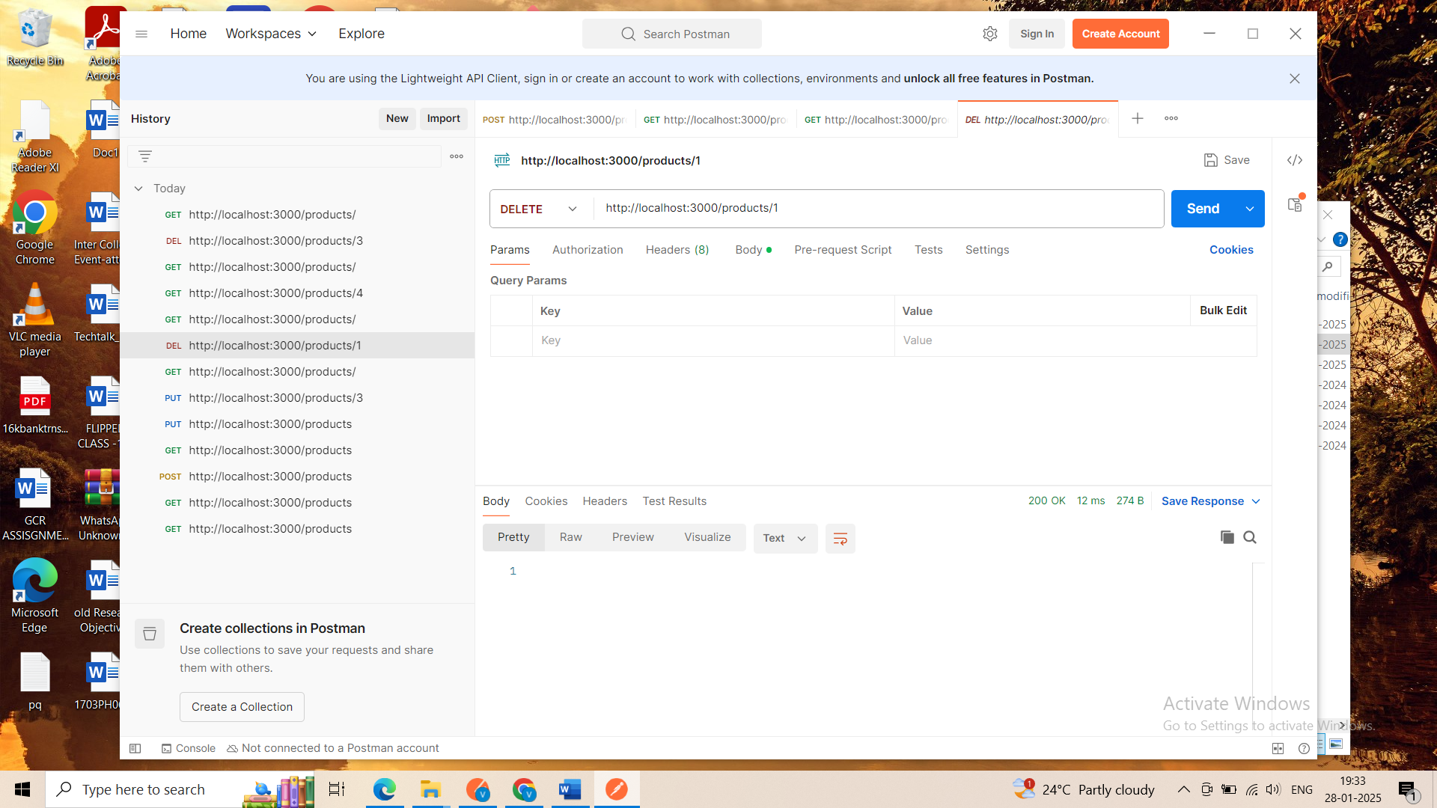
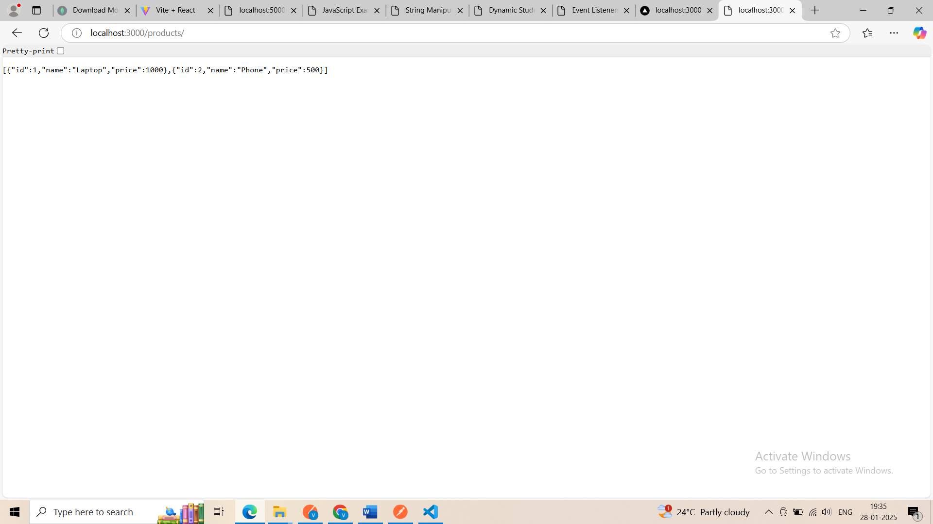
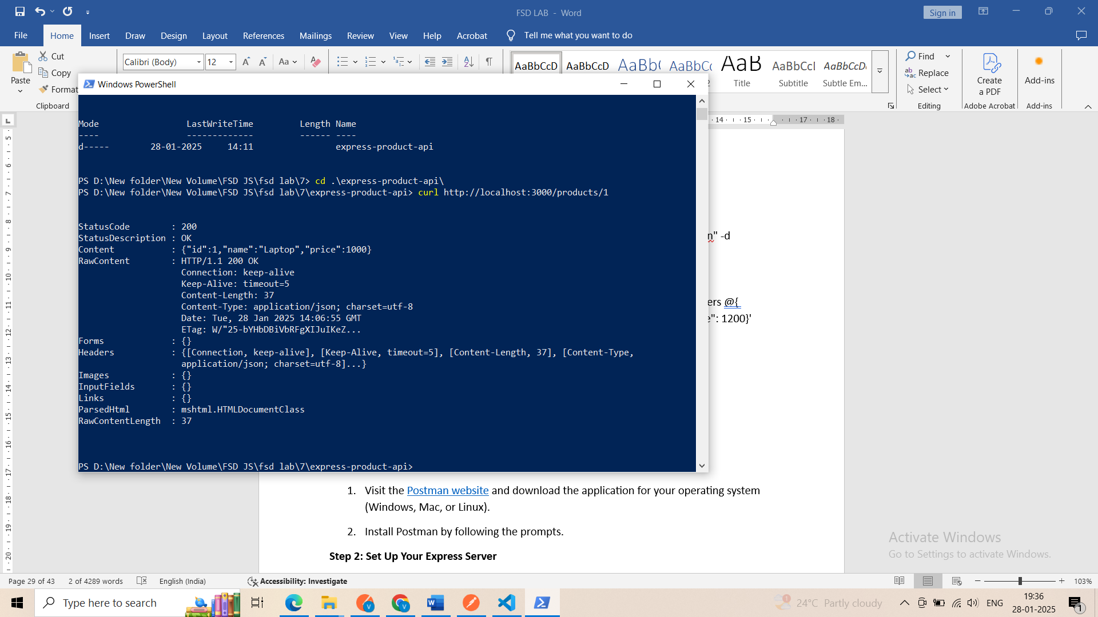

  - Install the MongoDB driver for Node.js. Create a Node.js script to connect to the shop database. Implement insert, find, update, and delete operations using the Node.js MongoDB driver. Define a product schema using Mongoose. Insert data into the products collection using Mongoose. Create an Express API with a /products endpoint to fetch all products. Use fetch in React to call the /products endpoint and display the list of products. Add a POST /products endpoint in Express to insert a new product. Update the Product List, After adding a product, update the list of products displayed in React.

Step 1: Setup Your Environment
- Install Node.js
  - Download and install Node.js from nodejs.org.
- Initialize a Node.js Project
mkdir mongodb-react-project
cd mongodb-react-project
npm init -y
- Install Required Dependencies
- Install the MongoDB driver, Mongoose, Express, and additional tools:
npm install express mongoose mongodb cors body-parser
Step 2: Set Up MongoDB
- Install MongoDB
  - Download and install MongoDB from mongodb.com.
Or
  - Download the latest version of MongoDB from MongoDB Community Server.
While installing you can choose complete or custom option
After installing the mongo db then set the path in system environment variable like
2. Add MongoDB to System PATH
To use mongod from any terminal, add the MongoDB binary folder to your PATH environment variable:
- Locate the bin folder in your MongoDB installation directory, e.g.:
C:\Program Files\MongoDB\Server\<version>\bin
- Add it to your PATH:
  - Press Win + S, search for Environment Variables, and open it.
  - Click Environment Variables in the dialog.
  - In the System Variables section, find and select Path, then click Edit.
  - Click New and add the full path to MongoDB's bin folder (e.g., C:\Program Files\MongoDB\Server\<version>\bin).
  - Click OK to save.
- Restart your terminal and try running:
mongod --version
If it outputs the version, mongod is now available.
- Start the MongoDB server: while starting server if you are getting any error then do
1.mkdir D:\New folder\New Volume\FSD JS\fsd lab\8new \data\db
2.D:\New folder\New Volume\FSD JS\fsd lab\8 new\data\db>
mongod --dbpath "D:\New folder\New Volume\FSD JS\fsd lab\8 new\data\db"
- Connect to MongoDB
  - Open a MongoDB shell: db compass or you can use mongosh also
mongo
  - Create a database named shop:
use shop

Step 3: Create a Node.js Script to Connect to MongoDB in mongodb-react-project folder
- Create server.js
  - Connect to MongoDB and implement CRUD operations.

const express = require('express');
const mongoose = require('mongoose');
const bodyParser = require('body-parser');
const cors = require('cors');

const app = express();
app.use(bodyParser.json());
app.use(cors());

const PORT = 5000;

// MongoDB connection
mongoose.connect('mongodb://localhost:27017/shop', {
useNewUrlParser: true,
useUnifiedTopology: true,
});

const db = mongoose.connection;
db.on('error', console.error.bind(console, 'Connection error:'));
db.once('open', () => {
console.log('Connected to MongoDB');
});

// Product schema using Mongoose
const productSchema = new mongoose.Schema({
name: String,
price: Number,
description: String,
});

const Product = mongoose.model('Product', productSchema);

// API Endpoints
// Fetch all products
app.get('/products', async (req, res) => {
try {
const products = await Product.find();
res.json(products);
} catch (error) {
res.status(500).send(error.message);
}
});

// Add a new product
app.post('/products', async (req, res) => {
try {
const newProduct = new Product(req.body);
await newProduct.save();
res.status(201).json(newProduct);
} catch (error) {
res.status(500).send(error.message);
}
});

// Update a product
app.put('/products/:id', async (req, res) => {
try {
const updatedProduct = await Product.findByIdAndUpdate(req.params.id, req.body, {
new: true,
});
res.json(updatedProduct);
} catch (error) {
res.status(500).send(error.message);
}
});

// Delete a product
app.delete('/products/:id', async (req, res) => {
try {
await Product.findByIdAndDelete(req.params.id);
res.status(204).send();
} catch (error) {
res.status(500).send(error.message);
}
});

// Start the server
app.listen(PORT, () => {
console.log(`Server running on http://localhost:${PORT}`);
});

Step 4: Create a React Frontend
- Set Up React App
npm create vite@latest frontend
cd frontend
npm install
- Install Axios
npm install axios
- Create Components
  - App.jsx
import React, { useState, useEffect } from 'react';
import axios from 'axios';

const App = () => {
const [products, setProducts] = useState([]);
const [newProduct, setNewProduct] = useState({ name: '', price: '', description: '' });

// Fetch products
useEffect(() => {
fetchProducts();
}, []);

const fetchProducts = async () => {
try {
const response = await axios.get('http://localhost:5000/products');
setProducts(response.data);
} catch (error) {
console.error('Error fetching products:', error);
}
};

const handleAddProduct = async () => {
try {
await axios.post('http://localhost:5000/products', newProduct);
setNewProduct({ name: '', price: '', description: '' });
fetchProducts(); // Refresh the product list
} catch (error) {
console.error('Error adding product:', error);
}
};

return (
<div style={{ padding: '20px' }}>
<h1>Product List</h1>
<ul>
{products.map((product) => (
<li key={product._id}>
{product.name} - ${product.price} ({product.description})
</li>
))}
</ul>

<h2>Add New Product</h2>
<div>
<input
type="text"
placeholder="Name"
value={newProduct.name}
onChange={(e) => setNewProduct({ ...newProduct, name: e.target.value })}
/>
<input
type="number"
placeholder="Price"
value={newProduct.price}
onChange={(e) => setNewProduct({ ...newProduct, price: e.target.value })}
/>
<input
type="text"
placeholder="Description"
value={newProduct.description}
onChange={(e) => setNewProduct({ ...newProduct, description: e.target.value })}
/>
<button onClick={handleAddProduct}>Add Product</button>
</div>
</div>
);
};

export default App;

Step 5: Run the Application
- Start the Backend Server
node server.js
- Start the React Frontend
cd frontend
npm run dev
- Access the Application
  - Backend API: http://localhost:5000/products
  - React App: http://localhost:3000

Outcome
- The React app displays a list of products fetched from the /products endpoint.
Using Postman or Browser
If your Node.js API is running, you can fetch the products using your GET endpoint:
- Open Postman or your browser.
http://localhost:5000/products

- Adding a new product updates the list dynamically without refreshing the page.
You now have a fully functional MongoDB-Node.js-Express-React app.
How to check which data are there in mongo db
============================
1. Using MongoDB Shell
- Start the MongoDB Shell:
  - Run mongosh (for modern versions) or mongo (for older versions) in your terminal.
- Switch to the shop Database:
use shop
- List All Collections:
show collections
You should see products.
- View All Documents in the products Collection:
db.products.find().pretty()
This will display all the products in a readable format.

2. Using MongoDB Compass
- Open MongoDB Compass:
  - Download and install MongoDB Compass if you don’t already have it.
- Connect to Your MongoDB Server:
  - Use the connection string mongodb://localhost:27017 (default for local installations).
- Select the shop Database:
  - In the left-hand menu, select the shop database.
- View the products Collection:
  - Click on the products collection, and all the documents (data) will be displayed in a tabular format.

In mongo db compass how to insert the data
{
"_id": {
"$oid": "64c99b1b503359fba2a153fb"
},
"name": "Wireless Headphones",
"price": 15000,
"description": "Noise-canceling wireless headphones with long battery life."
}

o/p:
